NSU Physics Lab:
Simulation of a Capacitor- PhETand Measurements of Capacitors wired in Series and Parallel

EQUIPMENT REOUIRED

- PhET Capacitor Lab
- Logger Pro Program
- MS Windows Compatible Computer

Purpose

Explore the properties of a single simulated capacitor. Calculate and measure the capacitance of capacitors wired in series and parallel and other combinations.

Investigation 1:

Setup

- Start up the Computer

- Open your Internet Browser

- Go to http://phet.colorado.edu/en/simulation/capacitor-lab

- Click on the “Run Now” button

- You should see the image shown on the next page.
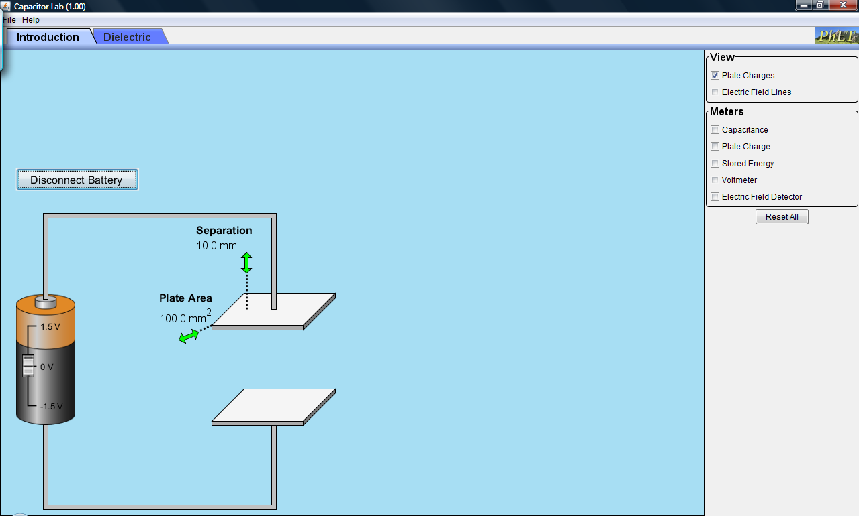

(6) Check the boxes indicated on the following image and drag the voltmeter leads so they touch the capacitor plates as shown below:

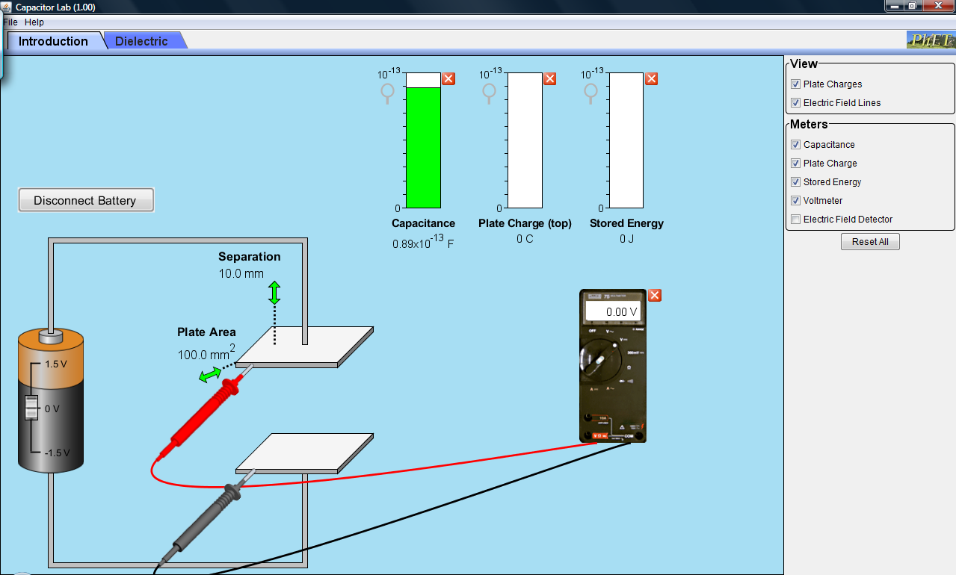

Part I. Relationship between charge and voltage.

Procedure

- Record the capacitance in the blank above table 1.

- Record the top plate charge Q for the voltage settings in table 1. (Move the battery voltage slider to obtain these settings)

Capacitance cap pF (note p = 10⁻¹²)

Table 1
Voltage (V) | Top Plate Charge (pC)
-1.5 | Q
-1.0 | Q
-0.5 | Q
0.0 | Q
0.5 | Q
1.0 | Q
1.5 | Q

- Switch back to the computer desktop (Press the “Alt-Esc” key combination) and start up the program Logger Pro. Download and extract the file http://www3.northern.edu/dolejsi/nsu_labs/Makeup_Capacitor_PhET.zip Open the File “Capacitor_PhET”

- Graph Charge on the y-axis versus Voltage on the x-axis. Use automatic curve fit (analyze menu) and select the direct proportion function. Paste the graph below:

Graph of Top Plate Charge vs Voltage



Record the slope of the line and compare it to the capacitance recorded above:

Slope = slope pF.

% diff with capacitance = % diff.

Minimize Logger Pro and switch to the PhET Capacitor Lab Simulation Window.

Part II. Geometric Factors of Capacitance (fixed separation, d)

Procedure

- Record the separation, d, in the blank above table 2.

- Record the capacitance, C, for the Area settings in table 2. (Move the Plate Area Arrow Control to obtain these settings)

Separation, d = d mm

Table 2
Plate Area (mm²) | Capacitance (pF)
100 | C
150 | C
200 | C
250 | C
300 | C
350 | C
400 | C

- Switch back to the computer desktop (Press the “Alt-Esc” key combination) and open up the Logger Pro Program. Click on Page 2.

- Graph Capacitance on the y-axis versus Area on the x-axis. Use automatic curve fit (analyze menu) and select the Proportional function. Paste the graph below:

Graph of Capacitance vs Plate Area

Record the slope of the line and compare it to ε_{o}/d (ε_{o} = 8.85 x 10⁻³ pF/mm)

Slope = slope pF/mm².

ε_{o}/d = ε_{o}/d pF/mm².

% diff = % diff.

Minimize Logger Pro and switch to the PhET Capacitor Lab Simulation Window.

Part III. Geometric Factors of Capacitance (fixed Area, A)

Procedure

- Record the Plate Area, A, in the blank above table 3.

- Record the capacitance, C, for the Separation settings in table 3. (Move the separation arrow to obtain these settings)

Plate Area = A mm²

Table 3
Separation (mm) | Capacitance (pF)
5.0 | C
6.0 | C
7.0 | C
8.0 | C
9.0 | C
10.0 | C

- Switch back to the computer desktop (Press the “Alt-Esc” key combination) and open up the Logger Pro Program. Go to page 3.

- Graph Capacitance on the y-axis versus plate separation on the x-axis. Use automatic curve fit (analyze menu) and select the inverse function. Paste the graph below:

Graph of Capacitance vs Plate Separation

Record the fit constant of the curve and compare it to ε_{o}.Area
(ε_{o} = 8.85 x 10⁻³ pF/mm)

Fit Constant = constant pF.mm.

ε_{o}.Area = ε_{o}*d pF.mm.

% diff = % diff.

Minimize Logger Pro and switch to the PhET Capacitor Lab Simulation Window.

Part IV. Relationship between Energy and voltage.

Procedure

- Record the Capacitance, C, in the blank above table 4.

- Record the stored energy, U, for the voltage settings in table 4. (Move the battery voltage slider to obtain these settings)

Capacitance = cap pF

Table 4
Voltage (V) | Stored Energy, U (pJ)
0.0 | U
0.25 | U
0.50 | U
0.75 | U
1.00 | U
1.25 | U

- Switch back to the computer desktop (Press the “Alt-Esc” key combination) and open up the Logger Pro Program. Go to page 4.

- Graph Energy on the y-axis versus Voltage on the x-axis. Use curve fit (analyze menu) and select the variable power A*X^n. Use 2 for the power. Paste the graph below:

Graph of Stored Energy vs Voltage

Record the fit constant and compare it to C/2.

Fit Constant = A pF.

C/2 = cap pF.

% diff = % diff.

Exit Logger Pro and PhET Capacitor Lab.

Investigation 2:

Setup

- An image of the digital multi-meter switched to read capacitance as shown (The three available settings read maximums 20 μF, 200 nF, and 2000 pF)

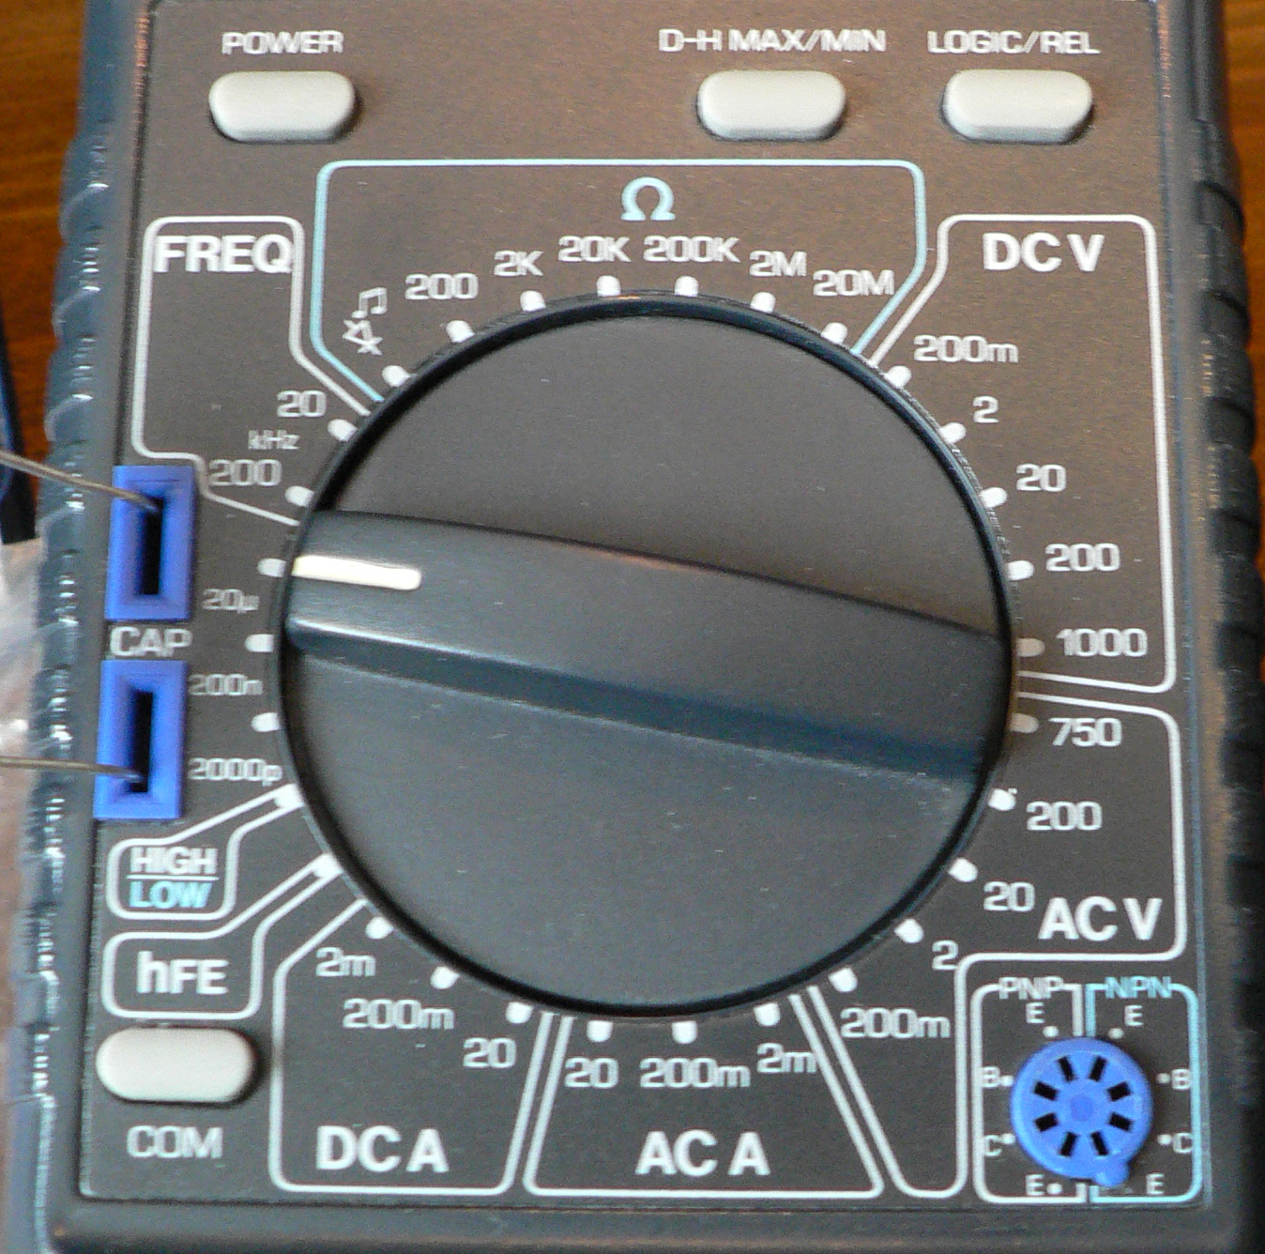

- Download and extract the file http://www3.northern.edu/dolejsi/nsu_labs/Makeup_Capacitor_PhET.zip for this lab. Pictures of measurements of capacitance for three capacitors C₁, C₂, and C₃ are shown in images C1.jpg, C2.jpg, and C3.jpg. Record these values in the table below

C₁ μF | C₂ μF | C₃ μF
cap | cap | cap

- The three capacitors are wired in series on a proto-board as shown in the figure below:

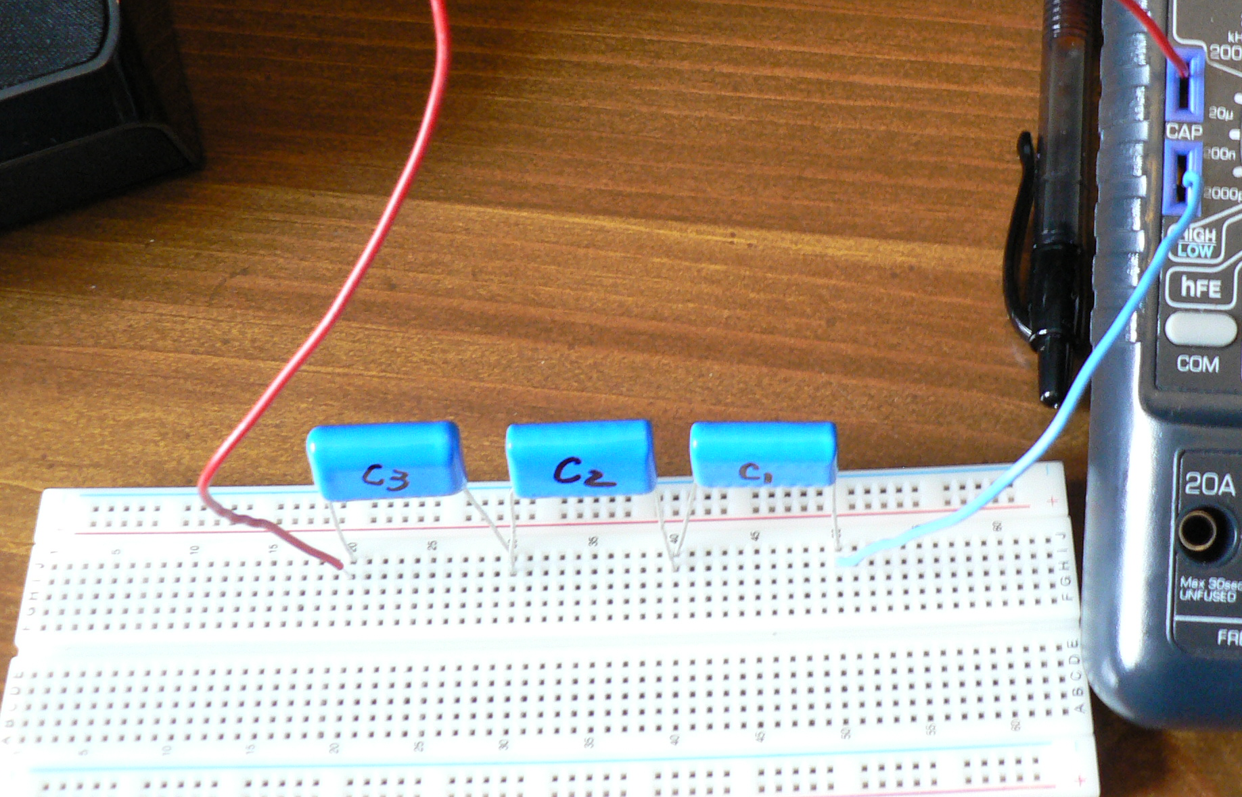

Calculate the total Capacitance for the series combination (show your work below. The measurement of the Capacitance of the series combination with the multi-meter is shown in the image Series.jpg. Record this reading below. Compare the calculated and measured values by computing the percent difference.

Series Capacitance (Calculated) = cap μF

Series Capacitance (Measured) = cap μF

Percent Difference = % diff.

- The three capacitors are wired in parallel on a proto-board as shown in the figure below:

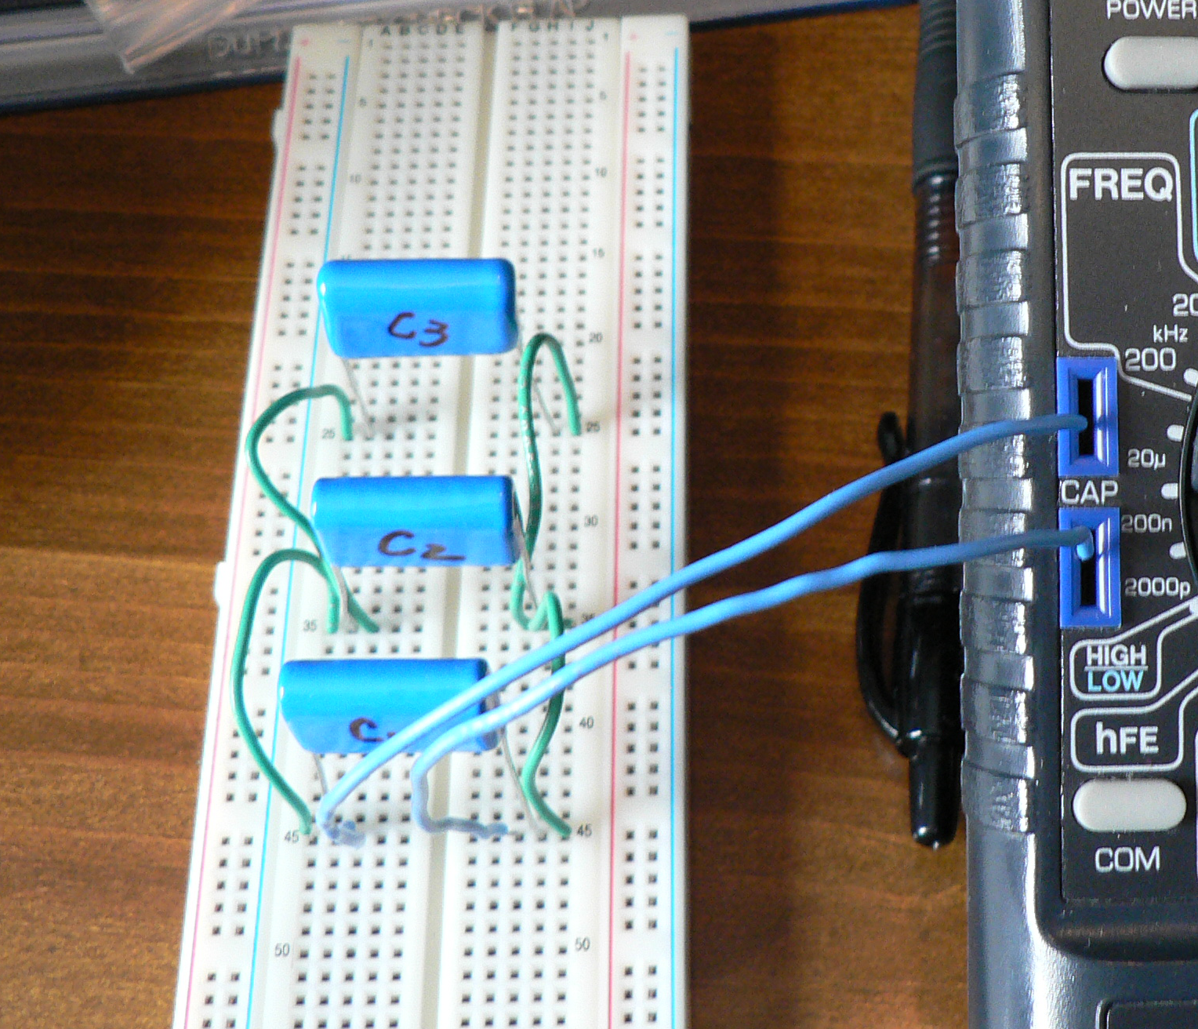

Calculate the total Capacitance for the parallel combination (show your work below. The measurement of the Capacitance of the parallel combination with the multi-meter is shown in the image Parallel.jpg. Record this reading below. Compare the calculated and measured values by computing the percent difference.

Parallel Capacitance (Calculated) = cap μF

Parallel Capacitance (Measured) = cap μF

Percent Difference = % diff.

- The three capacitors are wired in a series/parallel combination on a proto-board as shown in the figure below:

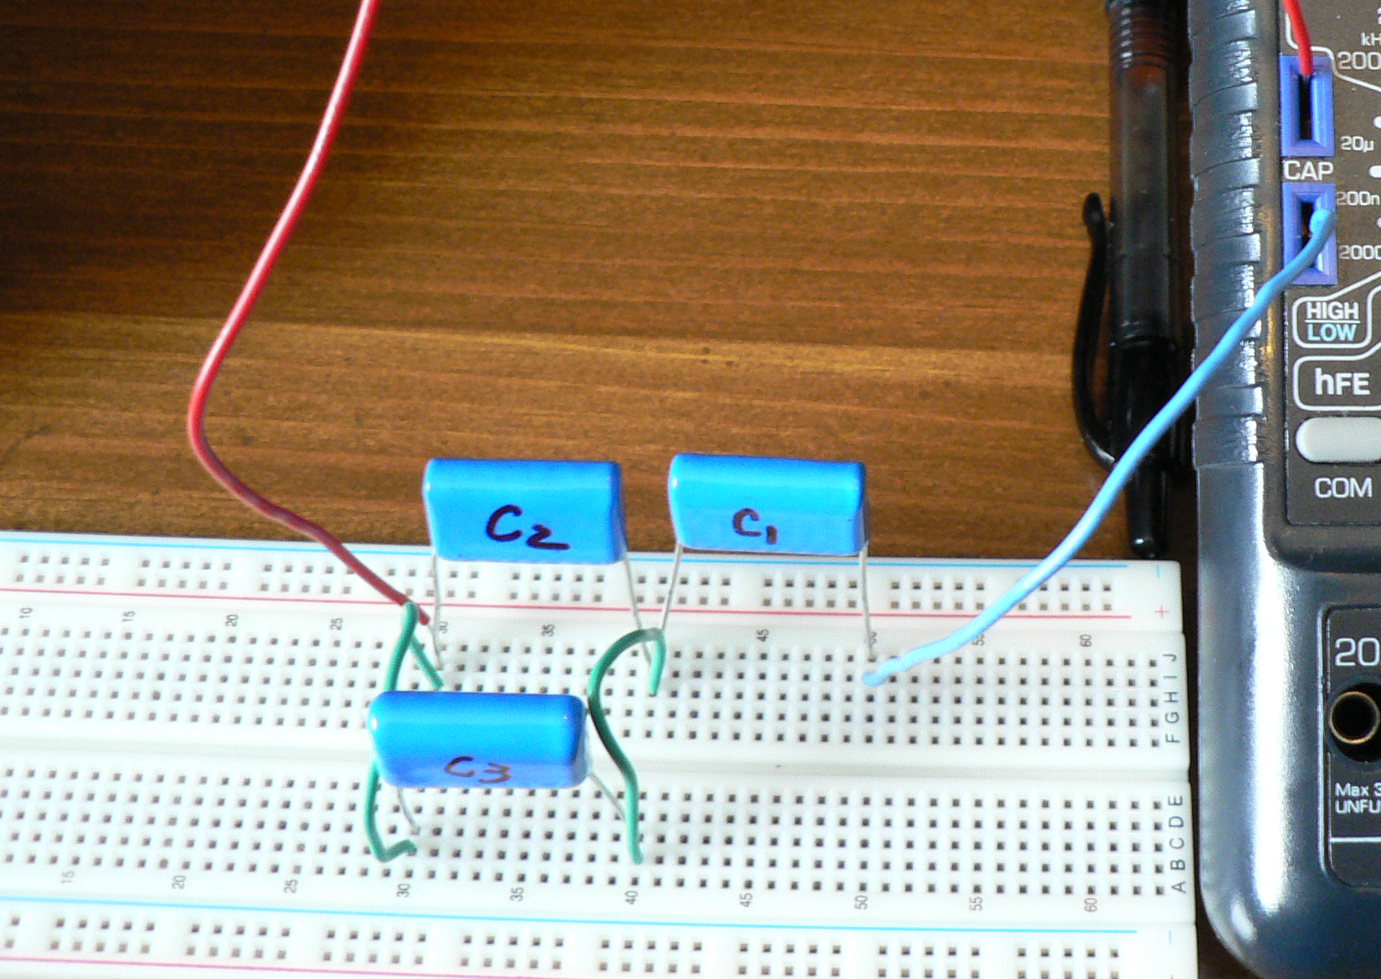

Calculate the total Capacitance for the parallel/series combination (show your work below. The measurement of the Capacitance of the series/parallel combination with the multi-meter is shown in the image Series_Parallel_Combo.jpg. Record this reading below. Compare the calculated and measured values by computing the percent difference.

Parallel/Series Capacitance (Calculated) = cap μF

Parallel/Series Capacitance (Measured) = cap μF

Percent Difference = % diff.

Conclusion

After group discussion, write a conclusion that summarizes the results of both investigations done in this experiment.

Click here to enter Conclusion.

