Newton’s Second Law Practice

I can find net force and use it to determine acceleration.
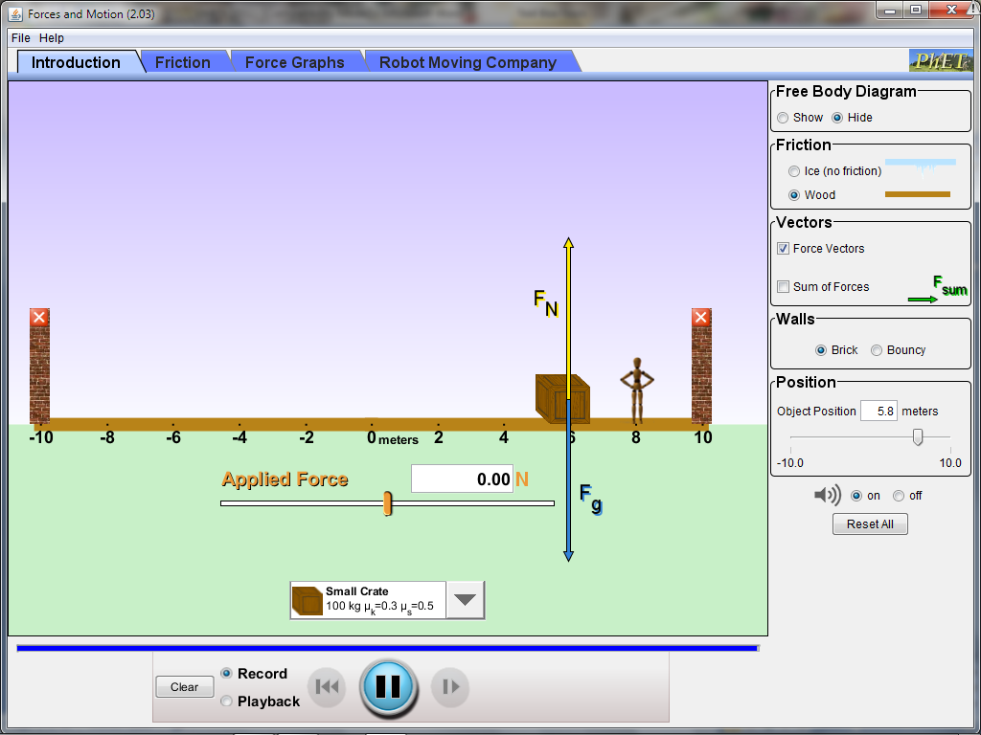
Get a computer and Google: Phet Force and Motion
Run the simulation. Turn on the check box that says Sum of Forces.
Are there any rules about forces and motion you can find out? What are they? How did you find these rules out from the simulation?
Rule 1:

Rule 2:

Rule 3:

Rule 4:

Rule 5:

Rule 6:

Rule 7:
1. The mass of the crate is 100kg. What is the weight of the crate?
How much is F_{g}?
How much is F_{N}?
How much Net Force is on the crate?
Draw a motion map:

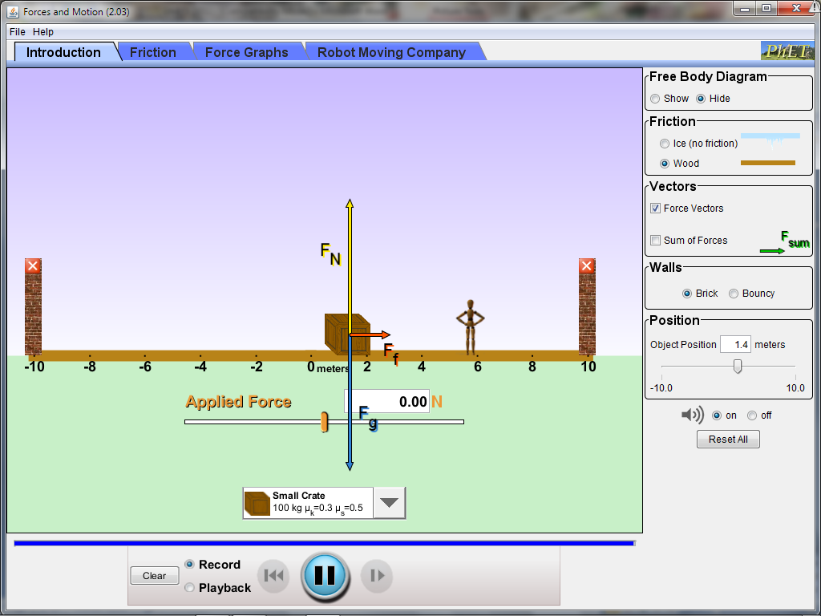
2. The Force of friction is 294 Newtons. What is the Net Force? What direction is it?

What must be true of the motion of the crate?

Draw a motion map:

3. The Force of friction is still 294 Newtons. The Applied Force is 1156 Newtons. What is the Net Force?
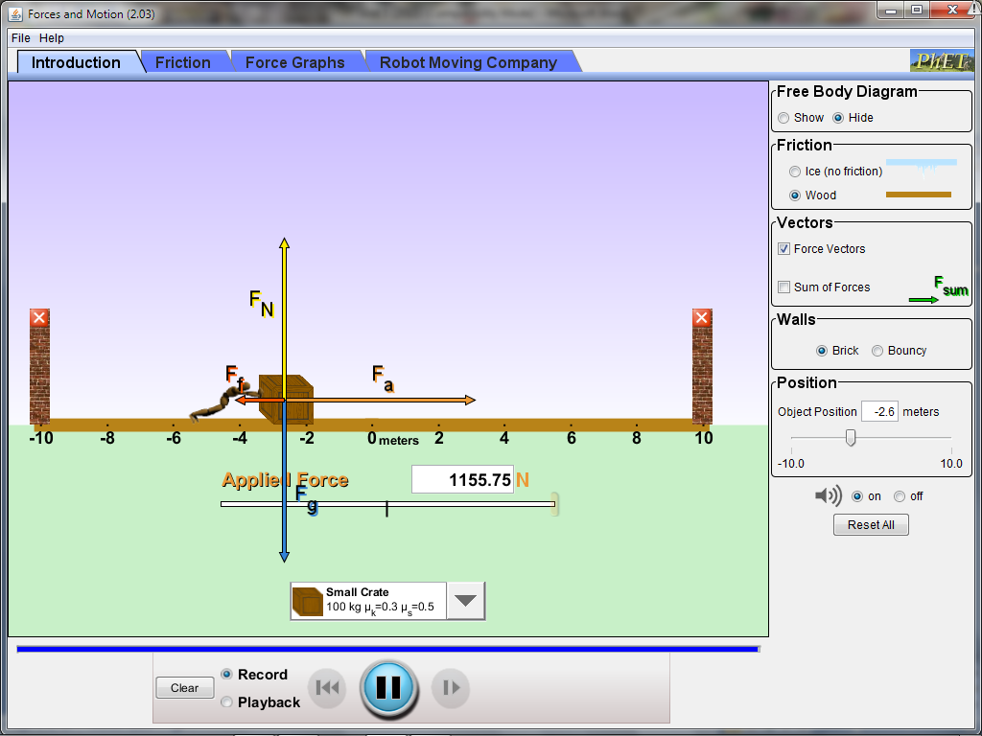
What direction is the Net Force?
What must be true of the motion of the crate?

Draw a motion map:

4. The skydiver has a weight of 900Newtons and feels 50Newtons of friction. (draw a diagram)
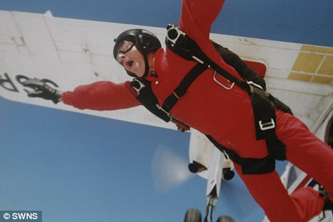
What is the Net Force?
What direction is the Net Force?
Draw a motion map:
What must be true of the motion of the skydiver?
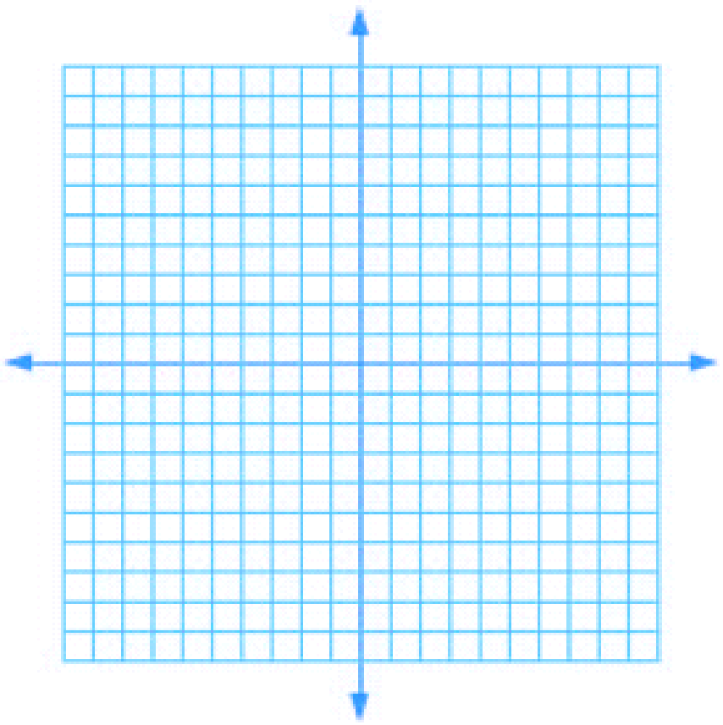

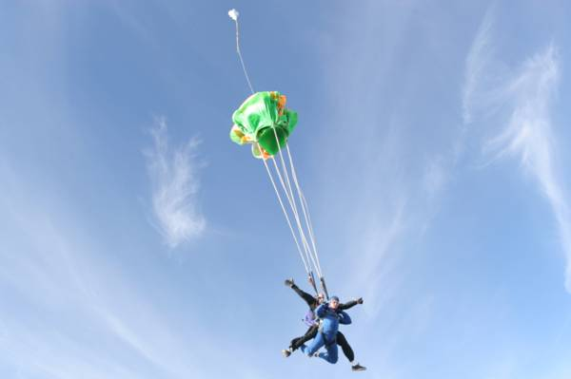
5. The skydivers have a weight of 2000Newtons and feel a force of tension of 2500Newtons. (draw a diagram)
What is the Net Force?
Draw a motion map:

What direction is the Net Force?
What must be true of the motion of the skydivers?

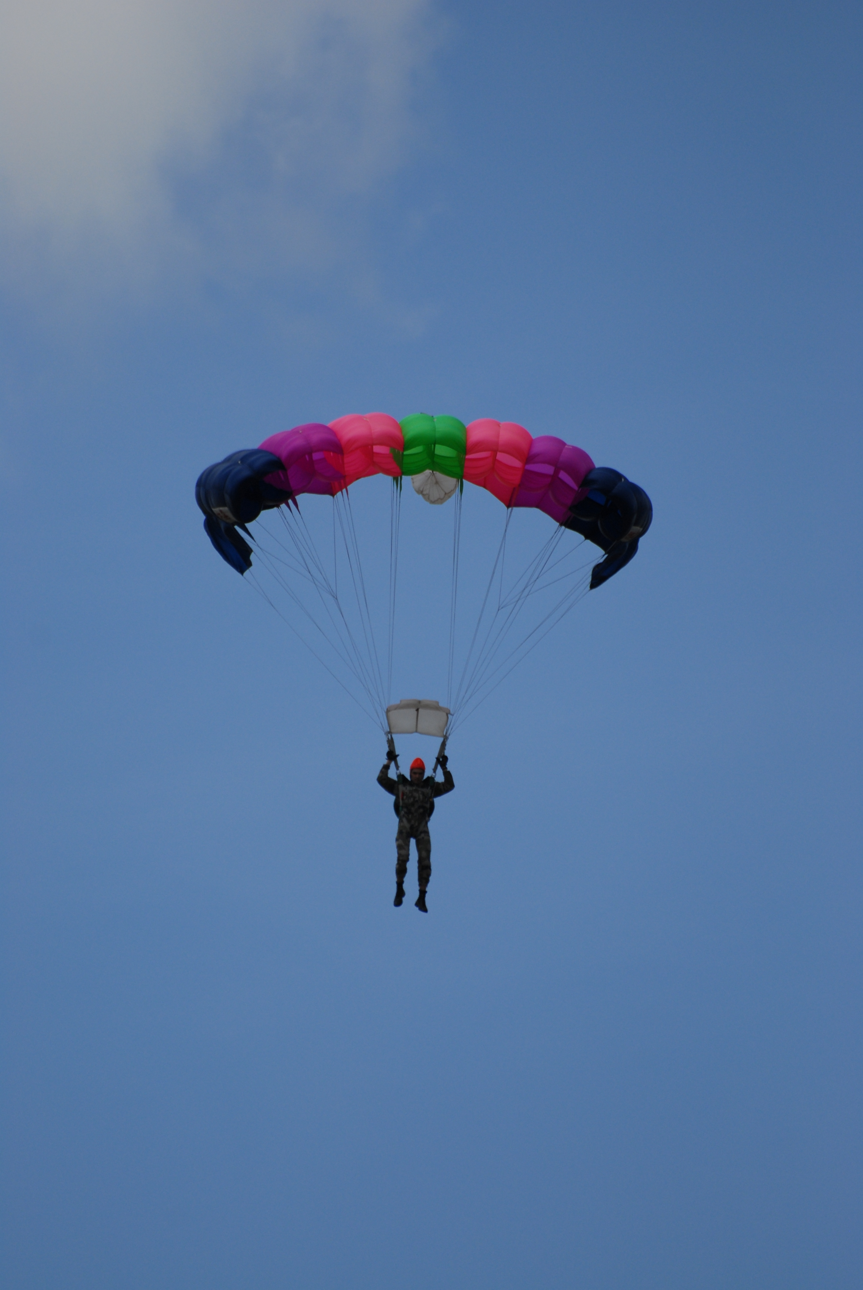
6. The skydiver has a weight of 1000 Newtons and is moving at a constant velocity. (draw a diagram)
What must be true of the Forces acting on her?
Draw a motion map:

7. The 900 Newton skydiver now feels a Force of Friction of 900 Newtons and a Force Normal of 900 Newtons. (draw a diagram)
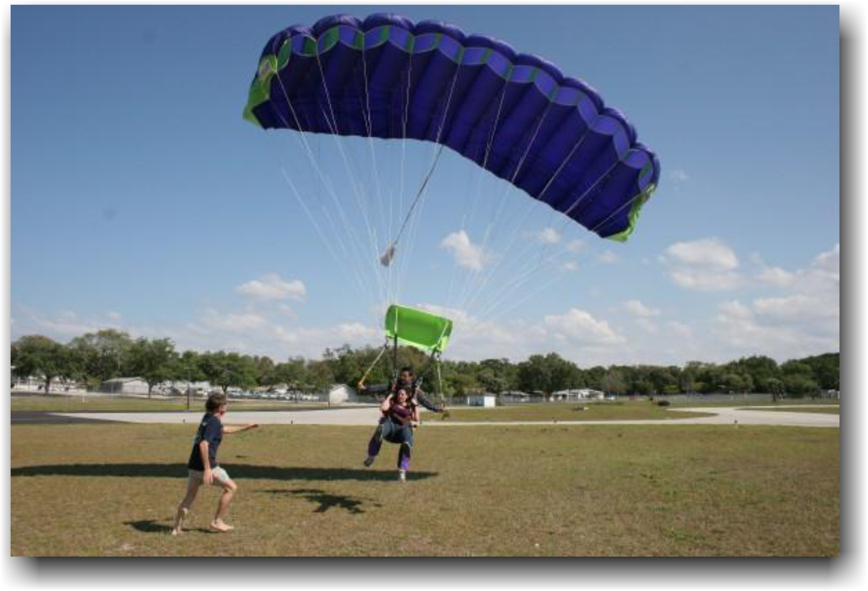
What is the Net Force on them?
What direction is the Net Force?
Draw a motion map:
What must be true of their motion?

